Comparative Analysis
Between HL7 C-CDA R1.1 CCD and epSoS PS v1.4
EU-US eHealth Cooperation Initiative
Document Version: v0.1
4/21/2013

Table of Contents
1 Document Revision History 4
2 Summary of Findings & Recommendations 5
3 Intended Audience 5
4 Background 5
4.1 Background of epSoS & C-CDA CCD 6
4.1.1 epSoS Background 6
4.1.2 C-CDA Background 6
4.2 Interoperability of EHR’s Work Stream Progress 6
5 Purpose 7
6 Standards Compared 7
7 Scope of the Analysis 9
8 Outcomes 11
9 Conclusions & Recommendations 11
9.1 Minimum (Core) Header Data Elements 11
9.2 Minimum (Core) Section Data Elements 11
10 Appendices 12
10.1 Appendix A: Memorandum of Understanding 12
10.2 Appendix B: Examples 12
10.3 Appendix C: References 12
10.4 Appendix D: Acronyms 12

List of Figures:
No table of figures entries found.
List of Tables:
No table of figures entries found.

Document Revision History
Version | Change Date | Originator | Section | Description of Changes
V0.1 | April 15, 2014 | Mark Roche | Document-level, Purpose, Standards Compared, Scope, Intended Audience | Edited name of document, page headers, Made Header numbering system automated. Authored Purpose, Standards Compared and Scope section. Added Intended Audience section.
V0.1 | April 16th, 2014 | Amanda Merrill | Background | Updated Background section
V0.1 | April 21st, 2014 | Amanda Merrill | All sections | Consolidated all edits & accepted suggested changes
V0.1 | April 22nd, 2014 | Mark Roche | Standards Compared, Scope | Added additional paragraphs and graphics to improve clarity of the document.
V0.1 | April 25, 2014 | Mark Roche | Standards compared, Scope | Clarified language around rationale for using C-CDA CCD. Inserted graphics in Scope section showing areas of elements overlap.

Summary of Findings & Recommendations

Intended Audience

Background
In 2010, the United States Department of Health and Human Services (US-DHHS) represented by the Secretary of Health and Human Services Kathleen Sebelius, and the European Commission (EC), represented by Vice President Neelie Kroes, signed a Memorandum of Understanding (MoU) with the following objectives:
- To strengthen global cooperation in eHealth/Health IT and foster a mutual understanding of challenges faced in advancing the effective use of eHealth/Health IT.

- To support an innovative collaborative community of public- and private-sector entities working toward the shared objective of developing, deploying, and using eHealth science and technology to empower individuals, support care, improve clinical outcomes, enhance patient safety and improve the health of populations.

While the MoU provided the objectives, it was necessary to create a road map to ensure the successful completion of the outlined objectives. The intent of the road map was to help guide the work and align the outcome and products with the MOU. The EU-US eHealth Cooperation Initiative was created as a way in which to systematically, cooperatively and successfully address and complete the items as outlined by the roadmap.
The EU-US eHealth Cooperation Initiative was formed under the guidance of the Office of the National Coordinator (ONC) Standards and Interoperability Framework(S&I) as a way to ensure the objectives of the MOU, the deliverables of the road map were achieved. The EU-US eHealth Cooperation Initiative was created as a platform for community members from both the EU and the US to collaborate on ways to address and potentially solve the challenges laid out in the objectives of the MOU. One of the areas of focus was the interoperability of EHR systems between the EU and the US. The “Interoperability of EHRs” workgroup was formed under the EU-US eHealth Cooperation Initiative to examine the challenges of transmitting patient data from one health system in one country to another health system in a different country.
Using the road map and MOU as a guide the Interoperability of EHRs work group set out to complete several of the road map deliverables. Those deliverables include, among other items, the EU-US standards mapping activity, and this document. The purpose of this document is to explain the methodology, process and outcomes of the mapping between the epSoS Patient Summary (EU) to the C-CDA CCD (US) standards (EU-US standards mapping activity).

Interoperability of EHR’s Work Stream Progress
Based on the objectives established in the MoU, the Interoperability of EHR work stream was initiated. This work stream aims to accelerate progress towards the widespread deployment and routine use of internationally recognized standards to support transnational interoperability of electronic health information and communication technology. The Work Group consists of both American and European stakeholders and convenes bi-weekly to further the development of the work stream’s deliverables. All meeting materials and artifacts are available to the community on the EU-US eHealth Collaboration Wiki homepage.
The Interoperability of EHR work group developed a Use Case that describes the need for an electronic clinical summary to be accessed in an emergency room encounter in a foreign country (be it in the EU or in the US) and for information on the emergency room care to be sent back to the patient's home country after the encounter. Upon completion of the Use Case, a Mapping Sub-Work Group of EU and US experts was formed to complete an analysis of the two standards identified to support the requirements of the use case. The Mapping SWG analyzed the structure, data elements, and value sets of the two standards and the results of the comparative analysis are presented in this white paper.

Purpose
The purpose of this document is to present and summarize comparative analysis between two document structure standards that are used to capture and exchange patient summary information in the EU and the US. The comparative analysis was performed as part of the S&I framework project: “EU-US eHealth Cooperation Initiative”.
A major outcome of the comparative analysis is the identification of the minimally required clinical data with associated vocabulary subsets for a patient summary form that would be exchanged on an international level. Therefore, the outcomes of this analysis will form the basis for creation of a new, internationally recognized document structure standard for Patient Summary, based on HL7 CDA R2.0. The international Patient Summary document accomplishes two objectives:
- Unambiguous interpretation of Patient Summary information by healthcare professionals on an international level.
- Enabling Patient Mediated, Patient Facilitated and Provider-to-Provider data exchanges.

Background of epSoS & C-CDA CCD
This paper analyzes the epSoS and C-CDA CCD standards. The sections below provide background on the context, history, and current status of these standards.

epSoS Background
The European eHealth Governance initiative is working to establish a governance structure for eHealth within Europe in order to ensure continuity of healthcare both at home and across borders. It is achieving this through the development of strategies, priorities, recommendations and guidelines designed to deliver eHealth in Europe in a coordinated way.
epSoS is an eHealth interoperability project funded by the European Commission. It aims at improving medical treatment of citizens while abroad by providing the healthcare provider with the necessary electronic and safe patient data. The goal of the project is to develop a service infrastructure that enables the exchange of patient data across borders. The EU released an eHealth action plan in 2012 and epSoS is cited in the plan as having defined how member states can cooperate and integrate their processes in order to deploy eHealth services across Europe. The EU, recently, adopted the epSoS Patient Summary document structure based on epSoS IG v1.4 (based on HL7 CDA R2 standard). epSOS was used as the basis for the mapping presented in this paper.

C-CDA Background
The HITECH Act is a U.S. statute within the American Recovery and Reinvestment Act of 2009 (ARRA). As part of the HITECH Act, the Centers for Medicare & Medicaid Services (CMS) administer incentives to eligible professionals and hospitals for meaningful use of certified EHRs. The US has selected the Patient Summary document structure based on C-CDA R1.1 CCD template (based on HL7 CDA R2) as a requirement for meaningful use of EHRs.
The Office of the National Coordinator for Health IT (ONC) established the S&I framework in January 2011 to facilitate and expand the secure, electronic movement and use of health information among organizations according to nationally recognized standards. The S&I Framework serves as the U.S. platform for Interoperability initiatives including the specification of standards for Meaningful Use. The EU-US eHealth Cooperation initiative is an affiliated project that operates within the S&I Framework.

Standards Compared

This comparative analysis compares two document structure standards used to capture and exchange Patient Summary information in European Union and the United States. Both of these standards are based on common standard developed by Health Level 7 (HL7): CDA R2.0. The following table summarizes details with respect to two standards.

 | 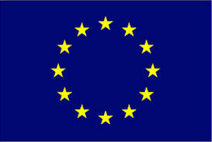 EU | 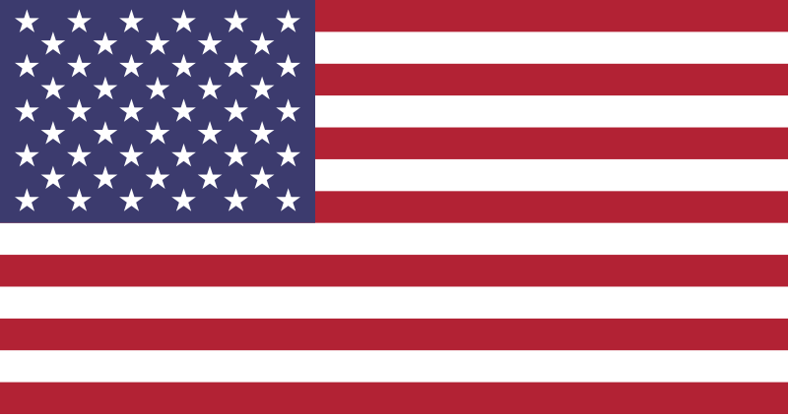 USA
Templates compared | Patient Summary (PS) | Continuity of Care Document (CCD)
Base Standard | HL7 CDA R2.0 | HL7 CDA R2.0
Standard Full Name | Smart Open Services for European Patients, Patient Summary | Consolidated Clinical Document Architecture, Continuity of Care Document
Work Package | WP 3.9 | Not Applicable
Document Full Name | D3.9.1 Appendix B1/B2 epSOS Semantic Implementation Guidelines | HL7 Implementation Guide for CDA® Release 2: IHE Health Story Consolidation, DSTU Release 1.1 (US Realm) Draft Standard for Trial Use
Document Short Name | D3.9.1 - Appendix B1/B2 | HL7 C-CDA R1.1
Document Version | 1.4 | Not Applicable
Publication Date | July 25, 2011 | July 2012
File Name | epSOS_D3.9.1_Appendix_B1_B2_Implementation_v1.4_20110725.pdf | CDAR2_IG_IHE_CONSOL_DSTU_R1dot1_2012JUL.pdf
File Location | TBD | https://www.hl7.org/documentcenter/private/standards/cda/CDAR2_IG_IHE_CONSOL_DSTU_R1dot1_2012JUL.zip
Background Note: | PS represents one of three document templates within epSoS Implementation Guide | CCD represents one of nine document templates within C-CDA Implementation Guide.

HL7 C-CDA Release 1.1 CCD was chosen for comparative analysis since C-CDA is one of required standards for exchange of health information in a structured format in the US. The standard is mandated by the US Code of Federal Regulations (CFR) Title 45, Subpart C, §170.205(a)(3): “Patient Summary Record Standard” as a requirement to achieve Meaningful Use Stage 2 of electronic health record adoption. There are two other standards allowed for exchange of structured Patient Summary information: ASTM’s Continuity of Care Record (CCR) and HL7 CDA R2 Continuity of Care Record (CCD)/HITSP C32. However, of the three aforementioned standards, C-CDA is being continuously updated and is most up to date in terms of data elements, and most importantly, in terms of vocabulary bindings (values used with data elements). C-CDA itself is a collection of different templates (clinical forms), one of which is Continuity of Care Document (CCD). It is the C-CDA CCD template that is used to exchange patient Summary information and therefore matches purpose and the use within this comparative analysis.

epSoS was chosen for comparative analysis because it was selected by a consortium of 45 beneficiaries (ministries of health, national/regional centers and industry participants) in 25 European countries as a base standard for cross-border exchange of electronic health record in Europe. epSOS has been conceived of as a pilot project designed to take place on a large scale, initially involving 12 EU-Member States and expanded to 23 Participating Nations (PN) since 1st of January 2011. The project will demonstrate that - based on European collaboration and the commitment of the Participating Nations - it is possible to improve the quality and safety of healthcare provided to patients outside their country of residence, through sharing of patient health information for the purposes of receiving treatment abroad.

Scope of the Analysis
The following graphics provides an overview of structural components that were analyzed between epSoS PS and C-CDA CCD standards and the phases (or steps) that were taken incrementally to complete the analysis. The graphics also shows how these analytical steps correspond to visual representation of Patient (Clinical) Summary document in HL7 CDA 2.0 document structure standard (Note: Since both epSoS PS and CCDA CCD have identical underlying standard, HL7 CDA R2.0, the visual document represents, on a basic level, both Patient Summaries):
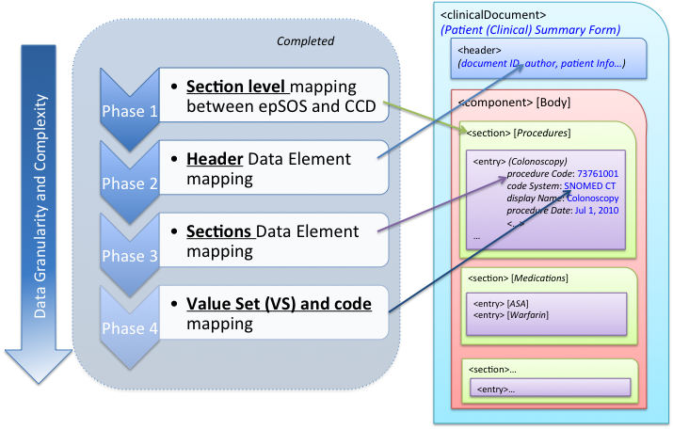

In General:
The scope of the analysis is aligned with the goal of the initiative and purpose of comparative analysis:
- Determine minimum Clinical Data Elements required for Patient Summary Form
- Determine Vocabulary Subsets that support aforementioned Clinical Data Elements
The analysis is therefore targeted to principally compare those structures between the two Patient Summary forms that contain (or carry) clinical information, namely data elements and value sets. For example:
- Clinical Data Element: Problem Code
- Value Set/Vocabulary: Problem Value Set (SNOMED CT code subset)

Additional structural components of document such as Document Sections were compared to the extent where these structural components are required to represent clinical information. For Example:
- Vaccination section was compared because it contains clinical data elements such as vaccination codes and vaccination dates, both of which are clinical data elements.

In Detail:
The scope of the comparative analysis between C-CDA R1.1 and epSoS v1.4 standards is limited to the templates (documents) that are used for Patient Summary information. Within C-CDA R1.1, Continuity of Care (CCD) template is used for Patient Summary and within epSoS v1.4, Patient Summary (PS) Form is used for Patient Summary.

Within Patient Summary templates, the analysis includes those sections that are overlapping. That is, those templates from epSoS that have corresponding template in C-CDA CCD are included in the comparative analysis. Outcomes section in this document lists all sections from epSoS PS and C-CDA CCD and shows overlapping sections.

Within overlapping sections (including header), the analysis compares clinical data elements from epSoS IG Chapters 10 and 11 (enumerated as Requirements with “R” followed by number sequence) that have corresponding clinical data element in C-CDA CCD. In addition to clinical data element mapping, the analysis documents cardinality, optionality and X-path for each mapped clinical data element.

For the overlapping clinical data elements, the analysis compares and maps value sets, and documents details such as value set binding, value set OID, coding system, etc.

Lastly, each value set is subjected to in-depth, code-level analysis and mapping where possible.

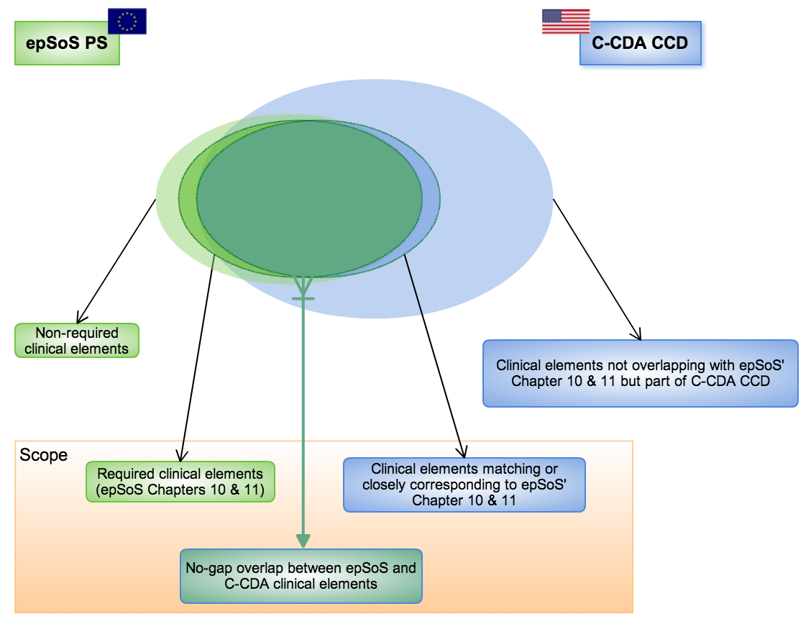

Outcomes

Conclusions & Recommendations

Minimum (Core) Header Data Elements

Minimum (Core) Section Data Elements

Appendices

Appendix A: Memorandum of Understanding

Appendix B: Examples

Appendix C: References

Appendix D: Acronyms

Source: http://wiki.siframework.org/EU-US+eHealth+Cooperation+Initiative, internet accessed on April 16, 2014.
Source: http://www.ecfr.gov/cgi-bin/text-idx?SID=def9cd4ed7017e02c9d8f6a53623a513&node=45:1.0.1.4.81&rgn=div5#45:1.0.1.4.81.2.27.4; internet accessed on April 25, 2014
Note: Please note that HL7 CDA R2 CCD and HL7 CDA R2 C-CDA R1.1 CCD are distinct standards.
Source: http://www.epsos.eu/home/about-epsos.html; internet accessed on April 22, 2014.
Source: http://www.epsos.eu/uploads/tx_epsosfileshare/epSOS_Legal_Perspectives_2013.pdf; internet accessed on April 16, 2014.

